

# Project

|  |  |
| --- | --- |
| First Saved | Sunday, February 3, 2019 |
| Last Saved | Sunday, February 3, 2019 |
| Product Version | 19.2 Release |
| Save Project Before Solution | No |
| Save Project After Solution | No |

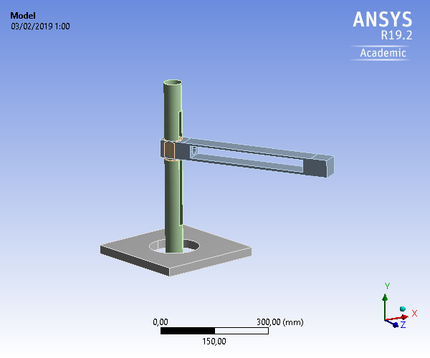

## Contents

* **Units**
* **Model (A4)**
  + Geometry
    - Parts
  + Materials
    - Aluminum Alloy NL
    - Structural Steel
  + Coordinate Systems
  + Connections
    - Contacts
      * Contact Regions
  + Mesh
  + **Static Structural (A5)**
    - Analysis Settings
    - Loads
    - Solution (A6)
      * Solution Information
      * Total Deformation
* **Material Data**
  + Aluminum Alloy NL
  + Structural Steel

## Units

TABLE 1

|  |  |
| --- | --- |
| Unit System | Metric (mm, kg, N, s, mV, mA) Degrees rad/s Celsius |
| Angle | Degrees |
| Rotational Velocity | rad/s |
| Temperature | Celsius |

## Model (A4)

### Geometry

TABLE 2  
Model (A4) > Geometry

|  |  |
| --- | --- |
| Object Name | *Geometry* |
| State | Fully Defined |
| **Definition** | |
| Source | C:\Users\pedro\Desktop\piezas listas\Brazo esfuerzos en Ansys\Simulación de Brazo Cilíndrico_files\dp0\SYS\DM\SYS.scdoc |
| Type | SpaceClaim |
| Length Unit | Meters |
| Element Control | Program Controlled |
| Display Style | Body Color |
| **Bounding Box** | |
| Length X | 459,49 mm |
| Length Y | 505,31 mm |
| Length Z | 585,11 mm |
| **Properties** | |
| Volume | 2,63e+006 mm³ |
| Mass | 7,2851 kg |
| Scale Factor Value | 1, |
| **Statistics** | |
| Bodies | 7 |
| Active Bodies | 4 |
| Nodes | 17185 |
| Elements | 8215 |
| Mesh Metric | None |
| **Update Options** | |
| Assign Default Material | No |
| **Basic Geometry Options** | |
| Solid Bodies | Yes |
| Surface Bodies | Yes |
| Line Bodies | Yes |
| Parameters | Independent |
| Parameter Key |  |
| Attributes | Yes |
| Attribute Key |  |
| Named Selections | Yes |
| Named Selection Key |  |
| Material Properties | Yes |
| **Advanced Geometry Options** | |
| Use Associativity | Yes |
| Coordinate Systems | Yes |
| Coordinate System Key |  |
| Reader Mode Saves Updated File | No |
| Use Instances | Yes |
| Smart CAD Update | Yes |
| Compare Parts On Update | No |
| Analysis Type | 3-D |
| Mixed Import Resolution | None |
| Clean Bodies On Import | No |
| Stitch Surfaces On Import | No |
| Decompose Disjoint Geometry | Yes |
| Enclosure and Symmetry Processing | Yes |

TABLE 3  
Model (A4) > Geometry > Parts

|  |  |  |  |  |  |  |  |
| --- | --- | --- | --- | --- | --- | --- | --- |
| Object Name | *SYS\Base cuadrada\Sólido1* | *SYS\Plaza brazo\Sólido1* | *SYS\soporte\Sólido1* | *SYS\Tuerca 2\Sólido1* | *SYS\Esparrago 40 cm\Superficie1* | *SYS\Esparrago 40 cm\Superficie2* | *SYS\Esparrago 35 cm\Superficie1* |
| State | Meshed | | | | Suppressed | | |
| **Graphics Properties** | | | | | | | |
| Visible | Yes | | | | No | | |
| Transparency | 1 | | | |  | | |
| **Definition** | | | | | | | |
| Suppressed | No | | | | Yes | | |
| Stiffness Behavior | Flexible | | | | | | |
| Coordinate System | Default Coordinate System | | | | | | |
| Reference Temperature | By Environment | | | | | | |
| Behavior | None | | | | | | |
| Thickness |  | | | | 300, mm | | |
| Thickness Mode |  | | | | Manual | | |
| Offset Type |  | | | | Middle | | |
| **Material** | | | | | | | |
| Assignment | Aluminum Alloy NL | | | | Structural Steel | | |
| Nonlinear Effects | Yes | | | | | | |
| Thermal Strain Effects | Yes | | | | | | |
| **Bounding Box** | | | | | | | |
| Length X | 349,17 mm | 334,3 mm | 63,396 mm | 59,749 mm | 22,509 mm | 247,21 mm | 34,218 mm |
| Length Y | 34,732 mm | 55,224 mm | 501,2 mm | 58,371 mm | 25,411 mm | 27,884 mm | 350,48 mm |
| Length Z | 348,83 mm | 447,92 mm | 56,021 mm | 53,773 mm | 15,496 mm | 337,42 mm | 28,952 mm |
| **Properties** | | | | | | | |
| Volume | 1,8652e+006 mm³ | 6,2805e+005 mm³ | 62595 mm³ | 74202 mm³ | 2,374e+005 mm³ | 1,063e+007 mm³ | 1,418e+007 mm³ |
| Mass | 5,1665 kg | 1,7397 kg | 0,17339 kg | 0,20554 kg | 1,8636 kg | 83,443 kg | 111,32 kg |
| Centroid X | -384,65 mm | -268,33 mm | -396,62 mm | -396,15 mm | -151,18 mm | -265,95 mm | -394,37 mm |
| Centroid Y | -147,62 mm | 152,07 mm | 89,064 mm | 142,47 mm | 153,38 mm | 152,56 mm | 79,211 mm |
| Centroid Z | 89,021 mm | 274,15 mm | 86,834 mm | 89,736 mm | 443,71 mm | 277,93 mm | 88,994 mm |
| Moment of Inertia Ip1 | 45710 kg·mm² | 55256 kg·mm² | 3920,8 kg·mm² | 99,642 kg·mm² | 95,442 kg·mm² | 1,8823e+006 kg·mm² | 1,4011e+006 kg·mm² |
| Moment of Inertia Ip2 | 90862 kg·mm² | 55090 kg·mm² | 106,41 kg·mm² | 97,873 kg·mm² | 104,48 kg·mm² | 1,8823e+006 kg·mm² | 15337 kg·mm² |
| Moment of Inertia Ip3 | 45690 kg·mm² | 936,52 kg·mm² | 3933,3 kg·mm² | 99,643 kg·mm² | 196,25 kg·mm² | 9797,5 kg·mm² | 1,4011e+006 kg·mm² |
| Surface Area(approx.) |  | | | | 791,32 mm² | 35432 mm² | 47268 mm² |
| **Statistics** | | | | | | | |
| Nodes | 422 | 1976 | 13468 | 1319 | 0 | | |
| Elements | 46 | 1036 | 6459 | 674 | 0 | | |
| Mesh Metric | None | | | | | | |
| **CAD Attributes** | | | | | | | |
| PartTolerance: | 0,00000001 | | | | | | |
| Color:143.149.175 |  | | | | | | |

### Coordinate Systems

TABLE 4  
Model (A4) > Coordinate Systems > Coordinate System

|  |  |
| --- | --- |
| Object Name | *Global Coordinate System* |
| State | Fully Defined |
| **Definition** | |
| Type | Cartesian |
| Coordinate System ID | 0, |
| **Origin** | |
| Origin X | 0, mm |
| Origin Y | 0, mm |
| Origin Z | 0, mm |
| **Directional Vectors** | |
| X Axis Data | [ 1, 0, 0, ] |
| Y Axis Data | [ 0, 1, 0, ] |
| Z Axis Data | [ 0, 0, 1, ] |

### Connections

TABLE 5  
Model (A4) > Connections

|  |  |
| --- | --- |
| Object Name | *Connections* |
| State | Fully Defined |
| **Auto Detection** | |
| Generate Automatic Connection On Refresh | Yes |
| **Transparency** | |
| Enabled | Yes |

TABLE 6  
Model (A4) > Connections > Contacts

|  |  |
| --- | --- |
| Object Name | *Contacts* |
| State | Fully Defined |
| **Definition** | |
| Connection Type | Contact |
| **Scope** | |
| Scoping Method | Geometry Selection |
| Geometry | All Bodies |
| **Auto Detection** | |
| Tolerance Type | Slider |
| Tolerance Slider | 0, |
| Tolerance Value | 2,2484 mm |
| Use Range | No |
| Face/Face | Yes |
| Face Overlap Tolerance | Off |
| Cylindrical Faces | Include |
| Face/Edge | No |
| Edge/Edge | No |
| Priority | Include All |
| Group By | Bodies |
| Search Across | Bodies |
| **Statistics** | |
| Connections | 6 |
| Active Connections | 2 |

TABLE 7  
Model (A4) > Connections > Contacts > Contact Regions

|  |  |  |  |  |  |  |
| --- | --- | --- | --- | --- | --- | --- |
| Object Name | *Contact Region* | *Contact Region 2* | *Contact Region 3* | *Contact Region 4* | *Contact Region 5* | *Contact Region 6* |
| State | Fully Defined | Suppressed | | Fully Defined | Suppressed | |
| **Scope** | | | | | | |
| Scoping Method | Geometry Selection | | | | | |
| Contact | 2 Faces | 3 Faces | | 2 Faces | 3 Faces | No Selection |
| Target | 2 Faces | No Selection | | 6 Faces | No Selection | |
| Contact Bodies | SYS\Plaza brazo\Sólido1 | | | SYS\soporte\Sólido1 | SYS\Tuerca 2\Sólido1 | SYS\Esparrago 40 cm\Superficie1 |
| Target Bodies | SYS\soporte\Sólido1 | SYS\Esparrago 40 cm\Superficie1 | SYS\Esparrago 35 cm\Superficie1 | SYS\Tuerca 2\Sólido1 | SYS\Esparrago 35 cm\Superficie1 | SYS\Esparrago 40 cm\Superficie2 |
| Protected | No | | | | | |
| Target Shell Face |  | Program Controlled | |  | Program Controlled | |
| Contact Shell Face |  | | | | | Program Controlled |
| **Definition** | | | | | | |
| Type | Bonded | | | | | |
| Scope Mode | Automatic | | | | | |
| Behavior | Program Controlled | | | | | |
| Trim Contact | Program Controlled | | | | | |
| Trim Tolerance | 2,2484 mm | | | | | |
| Suppressed | No | | | | | |
| **Advanced** | | | | | | |
| Formulation | Program Controlled | | | | | |
| Small Sliding | Program Controlled | | | | | |
| Detection Method | Program Controlled | | | | | |
| Penetration Tolerance | Program Controlled | | | | | |
| Elastic Slip Tolerance | Program Controlled | | | | | |
| Normal Stiffness | Program Controlled | | | | | |
| Update Stiffness | Program Controlled | | | | | |
| Pinball Region | Program Controlled | | | | | |
| **Geometric Modification** | | | | | | |
| Contact Geometry Correction | None | | | | | |
| Target Geometry Correction | None | | | | | |

### Mesh

TABLE 8  
Model (A4) > Mesh

|  |  |
| --- | --- |
| Object Name | *Mesh* |
| State | Solved |
| **Display** | |
| Display Style | Use Geometry Setting |
| **Defaults** | |
| Physics Preference | Mechanical |
| Element Order | Program Controlled |
| Element Size | Default (44,967 mm) |
| **Sizing** | |
| Use Adaptive Sizing | No |
| Growth Rate | Default (1,85) |
| Max Size | Default (89,935 mm) |
| Mesh Defeaturing | Yes |
| Defeature Size | Default (0,22484 mm) |
| Capture Curvature | Yes |
| Curvature Min Size | Default (0,44967 mm) |
| Curvature Normal Angle | Default (70,395°) |
| Capture Proximity | No |
| Bounding Box Diagonal | 899,35 mm |
| Average Surface Area | 3144, mm² |
| Minimum Edge Length | 1,4894e-004 mm |
| **Quality** | |
| Check Mesh Quality | Yes, Errors |
| Error Limits | Standard Mechanical |
| Target Quality | Default (0.050000) |
| Smoothing | Medium |
| Mesh Metric | None |
| **Inflation** | |
| Use Automatic Inflation | None |
| Inflation Option | Smooth Transition |
| Transition Ratio | 0,272 |
| Maximum Layers | 5 |
| Growth Rate | 1,2 |
| Inflation Algorithm | Pre |
| View Advanced Options | No |
| **Advanced** | |
| Number of CPUs for Parallel Part Meshing | Program Controlled |
| Straight Sided Elements | No |
| Rigid Body Behavior | Dimensionally Reduced |
| Triangle Surface Mesher | Program Controlled |
| Topology Checking | Yes |
| Pinch Tolerance | Default (0,40471 mm) |
| Generate Pinch on Refresh | No |
| Sheet Loop Removal | No |
| **Statistics** | |
| Nodes | 17185 |
| Elements | 8215 |

## Static Structural (A5)

TABLE 9  
Model (A4) > Analysis

|  |  |
| --- | --- |
| Object Name | *Static Structural (A5)* |
| State | Solved |
| **Definition** | |
| Physics Type | Structural |
| Analysis Type | Static Structural |
| Solver Target | Mechanical APDL |
| **Options** | |
| Environment Temperature | 22, °C |
| Generate Input Only | No |

TABLE 10  
Model (A4) > Static Structural (A5) > Analysis Settings

|  |  |
| --- | --- |
| Object Name | *Analysis Settings* |
| State | Fully Defined |
| **Step Controls** | |
| Number Of Steps | 1, |
| Current Step Number | 1, |
| Step End Time | 2,e-004 s |
| Auto Time Stepping | Program Controlled |
| **Solver Controls** | |
| Solver Type | Program Controlled |
| Weak Springs | Off |
| Solver Pivot Checking | Program Controlled |
| Large Deflection | Off |
| Inertia Relief | Off |
| **Rotordynamics Controls** | |
| Coriolis Effect | Off |
| **Restart Controls** | |
| Generate Restart Points | Program Controlled |
| Retain Files After Full Solve | No |
| Combine Restart Files | Program Controlled |
| **Nonlinear Controls** | |
| Newton-Raphson Option | Program Controlled |
| Force Convergence | Program Controlled |
| Moment Convergence | Program Controlled |
| Displacement Convergence | Program Controlled |
| Rotation Convergence | Program Controlled |
| Line Search | Program Controlled |
| Stabilization | Off |
| **Output Controls** | |
| Stress | Yes |
| Strain | Yes |
| Nodal Forces | No |
| Contact Miscellaneous | No |
| General Miscellaneous | No |
| Store Results At | All Time Points |
| **Analysis Data Management** | |
| Solver Files Directory | C:\Users\pedro\Desktop\piezas listas\Brazo esfuerzos en Ansys\Simulación de Brazo Cilíndrico_files\dp0\SYS\MECH\ |
| Future Analysis | None |
| Scratch Solver Files Directory |  |
| Save MAPDL db | No |
| Contact Summary | Program Controlled |
| Delete Unneeded Files | Yes |
| Nonlinear Solution | Yes |
| Solver Units | Active System |
| Solver Unit System | nmm |

TABLE 11  
Model (A4) > Static Structural (A5) > Loads

|  |  |  |  |  |  |  |
| --- | --- | --- | --- | --- | --- | --- |
| Object Name | *Pressure* | *Fixed Support* | *Pressure 2* | *Fixed Support 2* | *Fixed Support 3* | *Fixed Support 4* |
| State | Fully Defined | | | | | |
| **Scope** | | | | | | |
| Scoping Method | Geometry Selection | | | | | |
| Geometry | 3 Faces | | 2 Faces | 4 Faces | 2 Faces | 6 Faces |
| **Definition** | | | | | | |
| Type | Pressure | Fixed Support | Pressure | Fixed Support | | |
| Define By | Normal To |  | Normal To |  | | |
| Applied By | Surface Effect |  | Surface Effect |  | | |
| Magnitude | 5,e-006 MPa (ramped) |  | 1,e-005 MPa (ramped) |  | | |
| Suppressed | No | | | | | |

FIGURE 1  
Model (A4) > Static Structural (A5) > Pressure

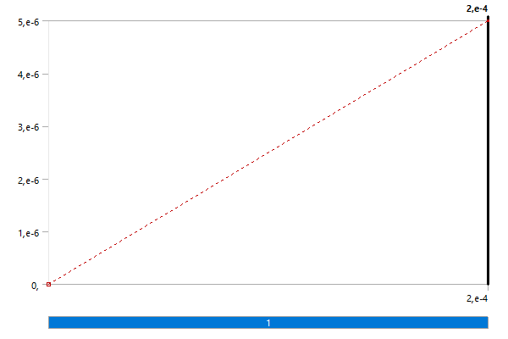

FIGURE 2  
Model (A4) > Static Structural (A5) > Pressure 2

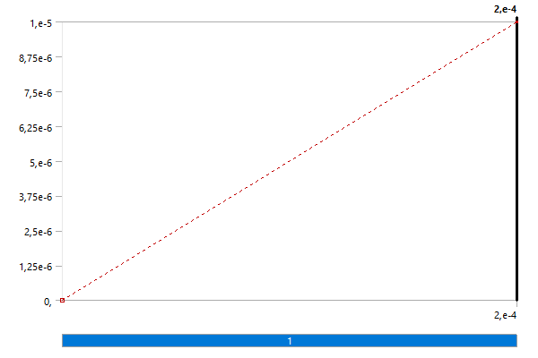

### Solution (A6)

TABLE 12  
Model (A4) > Static Structural (A5) > Solution

|  |  |
| --- | --- |
| Object Name | *Solution (A6)* |
| State | Solved |
| **Adaptive Mesh Refinement** | |
| Max Refinement Loops | 1, |
| Refinement Depth | 2, |
| **Information** | |
| Status | Done |
| MAPDL Elapsed Time | 7, s |
| MAPDL Memory Used | 343, MB |
| MAPDL Result File Size | 27,625 MB |
| **Post Processing** | |
| Beam Section Results | No |
| On Demand Stress/Strain | No |

TABLE 13  
Model (A4) > Static Structural (A5) > Solution (A6) > Solution Information

|  |  |
| --- | --- |
| Object Name | *Solution Information* |
| State | Solved |
| **Solution Information** | |
| Solution Output | Solver Output |
| Newton-Raphson Residuals | 0 |
| Identify Element Violations | 0 |
| Update Interval | 2,5 s |
| Display Points | All |
| **FE Connection Visibility** | |
| Activate Visibility | Yes |
| Display | All FE Connectors |
| Draw Connections Attached To | All Nodes |
| Line Color | Connection Type |
| Visible on Results | No |
| Line Thickness | Single |
| Display Type | Lines |

TABLE 14  
Model (A4) > Static Structural (A5) > Solution (A6) > Results

|  |  |
| --- | --- |
| Object Name | *Total Deformation* |
| State | Solved |
| **Scope** | |
| Scoping Method | Geometry Selection |
| Geometry | All Bodies |
| **Definition** | |
| Type | Total Deformation |
| By | Time |
| Display Time | Last |
| Calculate Time History | Yes |
| Identifier |  |
| Suppressed | No |
| **Results** | |
| Minimum | 0, mm |
| Maximum | 5,094e-009 mm |
| Average | 4,9193e-011 mm |
| Minimum Occurs On | SYS\Base cuadrada\Sólido1 |
| Maximum Occurs On | SYS\Base cuadrada\Sólido1 |
| **Minimum Value Over Time** | |
| Minimum | 0, mm |
| Maximum | 0, mm |
| **Maximum Value Over Time** | |
| Minimum | 1,0188e-009 mm |
| Maximum | 5,094e-009 mm |
| **Information** | |
| Time | 2,e-004 s |
| Load Step | 1 |
| Substep | 4 |
| Iteration Number | 5 |

FIGURE 3  
Model (A4) > Static Structural (A5) > Solution (A6) > Total Deformation

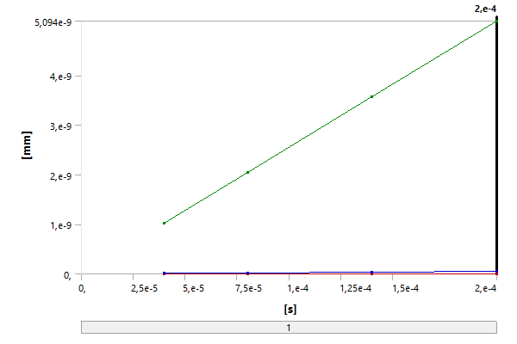

TABLE 15  
Model (A4) > Static Structural (A5) > Solution (A6) > Total Deformation

|  |  |  |  |
| --- | --- | --- | --- |
| Time [s] | Minimum [mm] | Maximum [mm] | Average [mm] |
| 4,e-005 | 0, | 1,0188e-009 | 9,8392e-012 |
| 8,e-005 | 2,0376e-009 | 1,9678e-011 |
| 1,4e-004 | 3,5658e-009 | 3,4435e-011 |
| 2,e-004 | 5,094e-009 | 4,9193e-011 |

FIGURE 4  
Model (A4) > Static Structural (A5) > Solution (A6) > Total Deformation > Figure

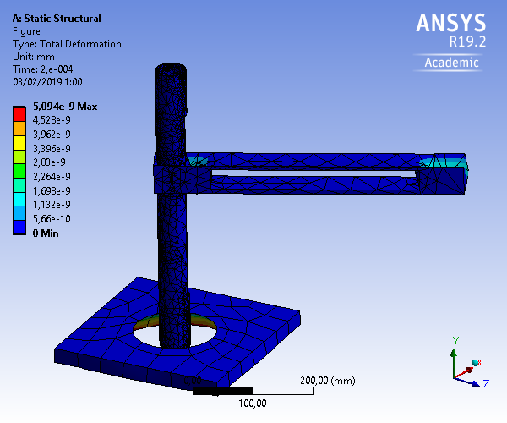

FIGURE 5  
Model (A4) > Static Structural (A5) > Solution (A6) > Total Deformation > Figure 2

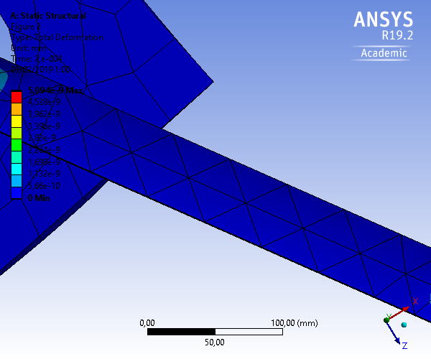

## Material Data

### Aluminum Alloy NL

TABLE 16  
Aluminum Alloy NL > Constants

|  |  |
| --- | --- |
| Density | 2,77e-006 kg mm^-3 |
| Specific Heat | 8,75e+005 mJ kg^-1 C^-1 |

TABLE 17  
Aluminum Alloy NL > Isotropic Elasticity

|  |  |  |  |  |
| --- | --- | --- | --- | --- |
| Young's Modulus MPa | Poisson's Ratio | Bulk Modulus MPa | Shear Modulus MPa | Temperature C |
| 71000 | 0,33 | 69608 | 26692 |  |

TABLE 18  
Aluminum Alloy NL > Bilinear Isotropic Hardening

|  |  |  |
| --- | --- | --- |
| Yield Strength MPa | Tangent Modulus MPa | Temperature C |
| 280, | 500, |  |

TABLE 19  
Aluminum Alloy NL > Color

|  |  |  |
| --- | --- | --- |
| Red | Green | Blue |
| 130, | 181, | 143, |

### Structural Steel

TABLE 20  
Structural Steel > Constants

|  |  |
| --- | --- |
| Density | 7,85e-006 kg mm^-3 |
| Coefficient of Thermal Expansion | 1,2e-005 C^-1 |
| Specific Heat | 4,34e+005 mJ kg^-1 C^-1 |
| Thermal Conductivity | 6,05e-002 W mm^-1 C^-1 |
| Resistivity | 1,7e-004 ohm mm |

TABLE 21  
Structural Steel > Color

|  |  |  |
| --- | --- | --- |
| Red | Green | Blue |
| 132, | 139, | 179, |

TABLE 22  
Structural Steel > Compressive Ultimate Strength

|  |
| --- |
| Compressive Ultimate Strength MPa |
| 0, |

TABLE 23  
Structural Steel > Compressive Yield Strength

|  |
| --- |
| Compressive Yield Strength MPa |
| 250, |

TABLE 24  
Structural Steel > Tensile Yield Strength

|  |
| --- |
| Tensile Yield Strength MPa |
| 250, |

TABLE 25  
Structural Steel > Tensile Ultimate Strength

|  |
| --- |
| Tensile Ultimate Strength MPa |
| 460, |

TABLE 26  
Structural Steel > Isotropic Secant Coefficient of Thermal Expansion

|  |
| --- |
| Zero-Thermal-Strain Reference Temperature C |
| 22, |

TABLE 27  
Structural Steel > S-N Curve

|  |  |  |
| --- | --- | --- |
| Alternating Stress MPa | Cycles | Mean Stress MPa |
| 3999, | 10, | 0, |
| 2827, | 20, | 0, |
| 1896, | 50, | 0, |
| 1413, | 100, | 0, |
| 1069, | 200, | 0, |
| 441, | 2000, | 0, |
| 262, | 10000 | 0, |
| 214, | 20000 | 0, |
| 138, | 1,e+005 | 0, |
| 114, | 2,e+005 | 0, |
| 86,2 | 1,e+006 | 0, |

TABLE 28  
Structural Steel > Strain-Life Parameters

|  |  |  |  |  |  |
| --- | --- | --- | --- | --- | --- |
| Strength Coefficient MPa | Strength Exponent | Ductility Coefficient | Ductility Exponent | Cyclic Strength Coefficient MPa | Cyclic Strain Hardening Exponent |
| 920, | -0,106 | 0,213 | -0,47 | 1000, | 0,2 |

TABLE 29  
Structural Steel > Isotropic Elasticity

|  |  |  |  |  |
| --- | --- | --- | --- | --- |
| Young's Modulus MPa | Poisson's Ratio | Bulk Modulus MPa | Shear Modulus MPa | Temperature C |
| 2,e+005 | 0,3 | 1,6667e+005 | 76923 |  |

TABLE 30  
Structural Steel > Isotropic Relative Permeability

|  |
| --- |
| Relative Permeability |
| 10000 |